21.89: (a) From Eq. (22.9), 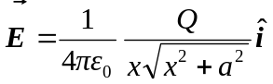
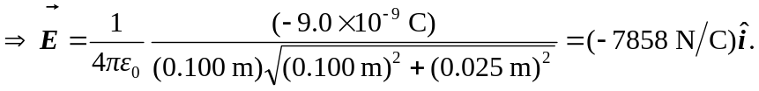
b) The electric field is less than that at the same distance from a point charge (8100 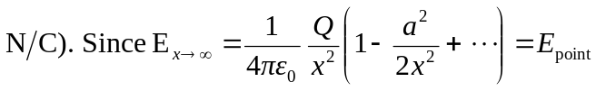–(Higher order terms).
c) For a 1% difference, we need the next highest term in the expansion that was left off to be less than 0.01:
